Meeting 19
Course / Class #: CECS 4800

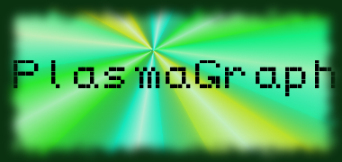
Date: 13 February 2014
Project Name: PlasmaGraph
Has been done:
1) Unit Testing: Data Sets, CSV reading, etc.
2) Additional changes to GUI-related classes. (Changed scaling for DataSetView, and changed the Menu Bar a bit.)
3) Work on the Matlab Data Reading.
a) Elicit more data files from the plasma laboratory.
b) Expanded DataSet and DataColumn classes.
c) Tested MatlabReader class with 4 different files.
4) Interpolation done. (Implemented a Spline interpolation method, and has additional tools to implement other types of interpolation.)
What will be done:
1) Interpolation testing will be implemented. Outlier Search will be implemented.
2) Fix errors produced in MatlabReader by .mat files with different lengths of columns.
3) Fix errors produced in MatlabReader by .mat files with null values.
4) Meet with client. Present options for Outlier Searching. (Faster but partially manual versus Slower but automated.)
5) Finish the error reporting system.
6) Work on next versions of the SRS, SDD, and SPMP documents.

Materials Used: 2x Computers, Internet connections, Microsoft Visio / Dia (Diagramming Tools), Eclipse / NetBeans IDE (Programming Tools).

Group Members: ________________________________
Gerardo A. Navas

________________________________
Daniel Quintini
Professor:

________________________________
Prof. Luis A. Ortiz

